Contents

Chapter 1: INTRODUCTION 3

1.1 Project Introduction 3

1.2 Justification of the project 3

1.2.1 Background of the project 3

1.2.2 Problem of the project 3

1.3 Description of Project 4

1.3.1 Features of System 4

1.4 Overview of project 4

Chapter 2: Project Scope 5

2.1 Scope 5

2.2 Limitation 5

2.3 Aims 5

2.4 Objectives 5

Chapter 3: Development Methodology 5

3.1 Methodology 5

3.2 Design Pattern 7

3.3 System Architecture 8

Chapter 4: Work Breakdown Structure (WBS) / Scheduling 9

4.1 Work Breakdown Structure 9

4.2 Milestones 11

4.3 Scheduling / Gantt chart 12

Chapter 5: Risk Management 14

Chapter 6: Configuration Management 15

Conclusion 17

References 18

Table of Figures

Figure 1: Waterfall Model 6

Figure 2: MVC Design Pattern 8

Figure 3: Three Tier Architecture 8

Figure 4: Work Breakdown Structure 9

Figure 5: Duration of Work Break down Structure 10

Figure 6: Schedule for Gantt chart 13

Figure 7: Gantt chart 13

Figure 8: Listing folder directory 16

Figure 9: Git Repo 17

# Chapter 1: INTRODUCTION

## 1.1 Project Introduction

Today world, people wants very quick services. People does not wants to wait or run here and there for services. On the developing the new technology, people wants quicks and fast services for application so that they do not wants to be panic for the services. Also people wants saved their time also. In this project people will not have to be panic for the blood. They can’t get easily their number of donor and also they can fill up the form to donate their blood so that at time of emergency people can easily get blood from another people.

## 1.2 Justification of the project

### 1.2.1 Background of the project

Blood bank and donor management system is web application in where people can easily donate blood through form and also they can get services of searching required blood.

In this application user can get all the information of the blood donor and different blood groups available in each blood bank. This project aim is to provide transparency in this areas. This project also helps user to get blood from blood banks without any cost and hassle free.

This application is based on the user perspective which is user friendly. Design in this system are very user friendly. Using this application user can donate blood through this application and can get their needed blood at any time they want. This application is based on PHP, MySQL, HTML, CSS, and JavaScript and along with Laravel framework. This application can run anywhere at any time user wanted.

### 1.2.2 Problem of the project

At present, People only know blood donation through different media sources just like television, Facebook. The current system in the blood bank using manual system in where managing the donor’s information is very difficult. Their chances of losing the donor information in the manual system. Sometimes human error causes also the losing the data of information in this system. Besides that, errors might occur when the staff keeps more than one record for the same donor.

Also without any automated system, there is always problem of keeping record in the system like amount of blood in the store and types of donated blood in the blood banks. In the addition, there is no change in the record if the blood has expired or the quantity of the blood is below its level.

So to reduce those problem this system should automated so that all the information can recorded and the recorded information can be kept safely.

## 1.3 Description of Project

### 1.3.1 Features of System

System has some feature which makes the day to day easy and fast to the user and those features are mentioned below:

1. Blood donation event can be advertise

In this features user can get notification of blood donation event through online. User can get the time and place of the event.

1. Registering donor details

User can get feature to register their detail in the system so that people who needed blood can request them to get blood.

1. Requesting fresh blood to the donor from online

Donor details were already register in the database so that if people use internet then they can see the detail of the donor and call them for the blood in case of emergency.

1. Blood bank management system

The blood bank staffs can manage the blood stock starting from the blood collection, to blood screening, processing, storage, transference and transfusion through this system. Each process or work-flow can be traced from the database. The system will also raise alert to the staff whenever the blood quantity is below its par level or when the blood in stock has expired.

1. Reporting featuring

The system is able to generate pre-defined reports such as the list of donors, recipients, staffs, the blood quantity in the bank and charts.

## 1.4 Overview of project

This project gives to record the detail of donor. Also this project provide facilities to record the available blood in the blood bank. This system provide recording system of blood management system. This is the automated system to record data of blood. This system provide the searching facilities of donor details so that user may contact to them to request for blood in case of emergency.

# Chapter 2: Project Scope

## 2.1 Scope

This system can be used to extend the donation of organ in the hospital and record the information of management system in the hospital. Also in this system all the process and record of the management system can be store.

## 2.2 Limitation

This system has some limitation which are mentioned below:

* Online transaction cannot be made.
* If the server is not made large then there will be the problem of time taken to respond by the system.

## 2.3 Aims

* The aims of this blood bank management system is to provide quick services to the user and to provide automated system of searching of blood in case of emergency.
* Also to provide automated system of recording the information of blood donor, blood donation program and available blood in the blood banks.

## 2.4 Objectives

The objectives of developing this system are mentioned below:

* The main reasons of developing this software is to provide urgent blood needed to public in case of emergency and to advertise the blood donation program.
* Also to provide the searching facilities of blood which are needed for the people.
* To provide sufficient storage to store the data of donated blood and blood stock in the blood banks.
* To provide the facilities of blood stock management functions in the blood banks by recording the details of the donor and available blood.

# Chapter 3: Development Methodology

## 3.1 Methodology

To complete this system, I have used waterfall model. In this model different separated phase were made so that after completing one phase we can go another phase. This model is also known as “Linear Sequential life cycle model”. This model is very easy to understand and easy to learn. This life cycle each step to be completed to before move another step. There were different phase that were introduce in this model which are mentioned below:

* Requirement analysis
* Design
* Implementation
* Testing
* Deployment
* Maintenance

These phases were introduce in the waterfall model which will go into another phase after complete one phase and it move downward like waterfall. In this model one phase will not overlap another phase. But this model will not work for long project and also will not suitable for those program whose requirement will be changed time to time. The following diagram describe the waterfall model’s different phase.

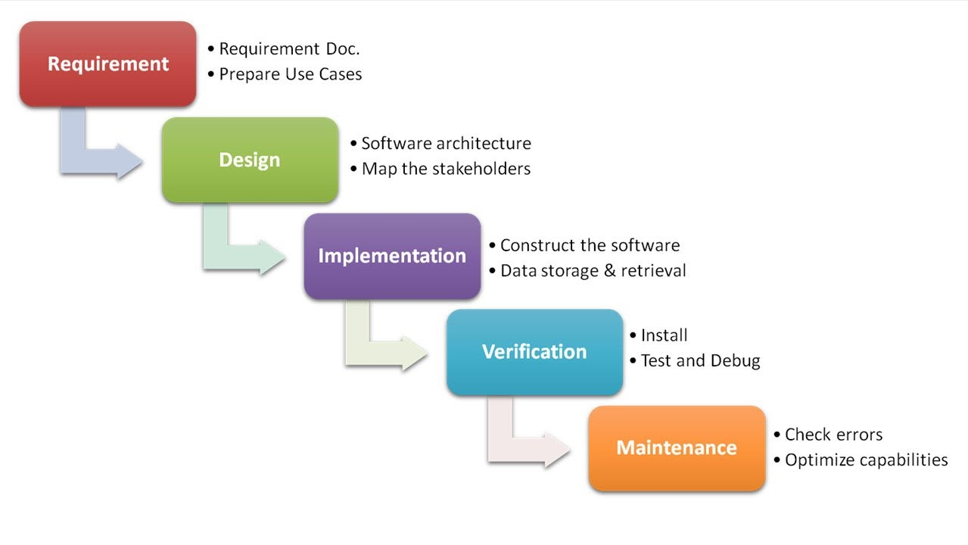

Figure 1: Waterfall Model

Comparison of water fall model with other model:

|  |  |  |  |
| --- | --- | --- | --- |
| **Properties of model** | **Waterfall model** | **Incremental Model** | **Spiral model** |
| Planning in early stage | Yes | Yes | Yes |
| Detailed Documentation | Necessary | Yes but not much | Yes |
| User Involvement | Only at the beginning | Intermediate | High |
| Duration | Long | Very Long | Long |
| Framework Type | Linear | Linear+ iterative | Linear+ iterative |

Due to this reasons I have chosen water fall model for my project.

## 3.2 Design Pattern

Design Pattern are good practices of using patterns by Object Oriented software. They provide best solution to developer of a problem which are occurred while developing software. These solutions were obtained by trial and error by numerous software developers over quite a substantial period of time. Among all design pattern, for this program MVC Design pattern were used.

MVC design pattern stands for Model, View and Controller. In this pattern, applications will be separated so that developer will feel easy to develop a product. This is the complete design pattern among all the design pattern. The explanation of this design pattern are mention below:

**Model**: In this part all data will be represented which were used in a software. But it will not contain logic part of the application.

**View**: in this part all the design will be visible so that user will know how to access in the application. This part contain only design view but will not describe how to program will manipulate.

**Controller**: in this part all flow of the data will controlled that are presented in the model and updates data of view part. It also helps to separates the model and view in the software.

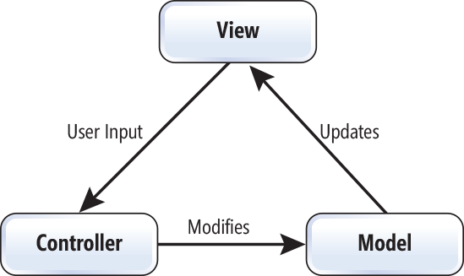

Figure 2: MVC Design Pattern

## 3.3 System Architecture

The process which show the conceptual diagram of the system is system architecture. Also it used to show the relation between different components which were used in the system.

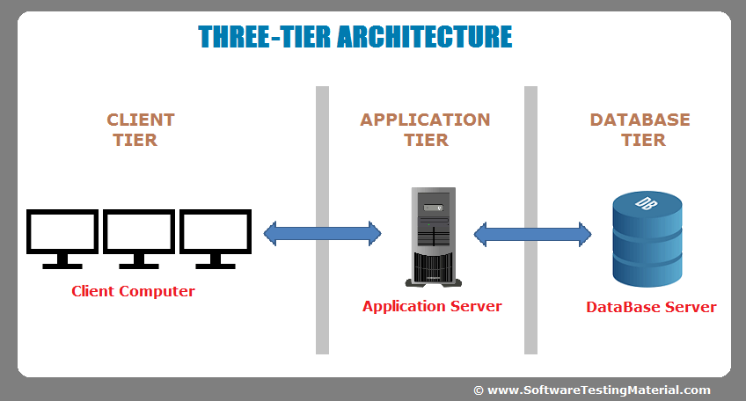

Figure 3: Three Tier Architecture

**Client tier:**

This tier is used which we use a software. This layer is also known as presentation layer whose main function is to communicate with application layer.

**Application tier:**

This layer is used to control an application’s functionality by performing detailed processing. This layer acts as a mediator between the Presentation and the Database layer. Complete business logic will be written in this layer.

**Database tier:**

The data is stored in this layer. Application layer communicates with Database layer to retrieve the data. It contains methods that connects the database and performs required action e.g.: insert, update, delete etc.

The reasons of using 3 tiers architecture in my project is that it will provide ease maintenance of code base, manage logic part of the software and view in the program and also they more independent of the servers.

# Chapter 4: Work Breakdown Structure (WBS) / Scheduling

## 4.1 Work Breakdown Structure

The process of breaking big project into sub tasks so that it will be easy to do task is known as work breakdown structure. This method is used by most of company to complete project in time. (workbreakdownstructure, 2018)

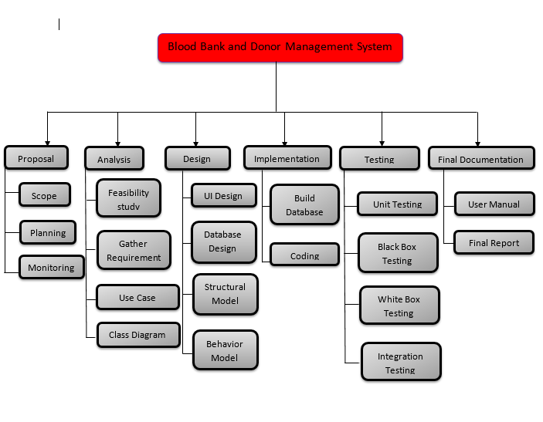

Figure 4: Work Breakdown Structure

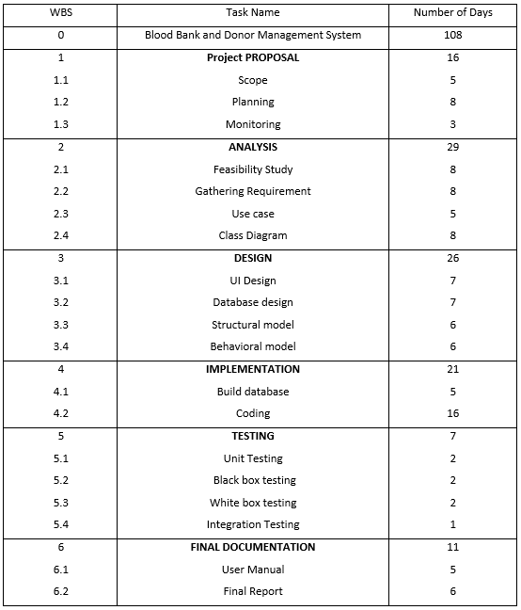

Figure 5: Duration of Work Break down Structure

## 4.2 Milestones

|  |  |  |  |
| --- | --- | --- | --- |
| **Title** | **Start Date** | **End Date** | **No. Of days** |
| **Project Proposal**  Scope  Planning  Monitoring | 25th March  3/25/2019  3/30/2019  4/7/2019 | 9th April  3/29/2019  4/6/2019  4/9/2019 | 16 Days  5 days  8 days  3 days |
| **Analysis**  Feasibility study  Gathering Requirement  Use case  Class Diagram | 10th April  4/10/2019  4/18/2019  4/26/2019  5/1/2019 | 8th May  4/17/2019  4/25/2019  4/30/2019  5/8/2019 | 29 Days  8 days  8 days  5 days  8 days |
| **Design**  UI Design  Database Design  Structural design  Behavior design | 9th May  5/9/2019  5/16/2019  5/23/2019  5/29/2019 | 3rd June  5/15/2019  5/22/2019  5/28/2019  6/3/2019 | 26 Days  7 days  7 days  6 days  6 days |
| **Implementation**  Build database  Coding | 4th June  6/4/2019  6/9/2019 | 24th June  6/8/2019  6/24/2019 | 21 Days  5 days  15 days |
| **Testing**  Unit Testing  Black box testing  White box testing  Integration testing | 25th June  6/25  6/27/2019  6/29/2019  7/1/2019 | 1st July  6/26/2019  6/28/2019  6/30/2019  7/1/2019 | 7 Days  2 days  2 days  2 days  1 days |
| **Final Documentation**  User Manual  Final report | 2nd July  7/2/2019  7/7/2019 | 12th July  7/6/2019  7/12/2019 | 11 days  5 days  6 days |

**Description of Milestones:**

**Project proposal:**

For doing this proposal I have allocated total 16 days and theses 16 days also divided into sub tasks they are scope (5 days), planning (8 days) and monitoring (3days).

**Analysis:**

To do analysis I have allocated total 29 days for the project. And they are also divided into sub tasks like feasibility study (8 days), gathering requirement (8 days), use case (5 days) and class diagram (8 days).

**Design:**

For design there will total 26 days will allocated and these 266 days also divide into sub task like UI design (7 days), database design (7 days), structural model (6 days) and behavior model (6 days).

**Implementation:**

For implementation there will be total 21 days. Among these 21 days, for build database there will 5 days and for coding there will 16 days.

**Testing:**

For testing, there will total 7 days and these testing also divide into different testing like unit testing (2 days), black box testing (2 days), white box testing (2 days) and integration days (1 days).

**Final Documentation:**

For final documentation there will total 11 days and these 11 days were also divide into different sub task and that were user manual (5 days) and final report (6 days).

## 4.3 Scheduling / Gantt chart

Gantt chart is a type graphical illustration of a schedule which helps to track, plan and co-ordinate the different sub tasks in a project. It is used for planning and scheduling of project tasks. We can identify what various activities are to be carried out using Gantt chart. This is the chart which gives the information about the time scale, what activities are overlapped with other activities, start date, end date of the project.

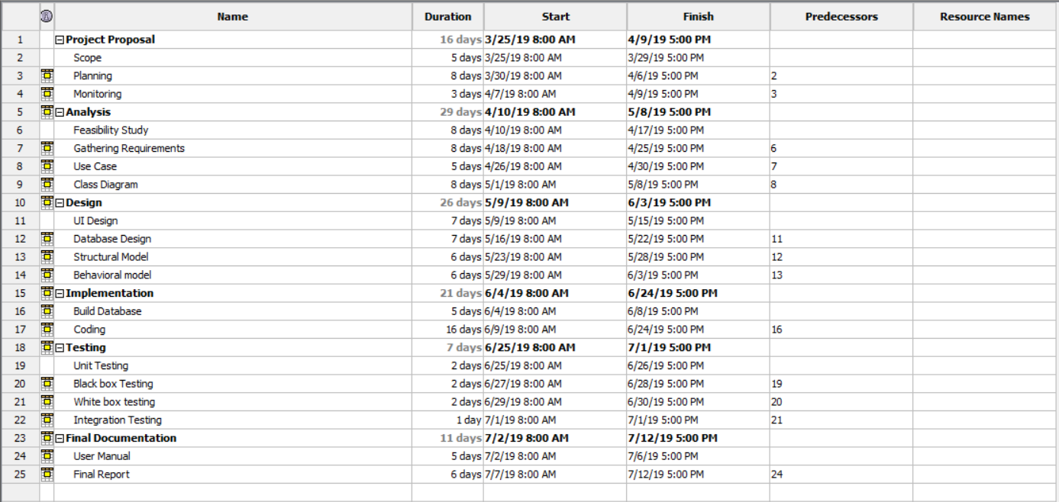

Figure 6: Schedule for Gantt chart

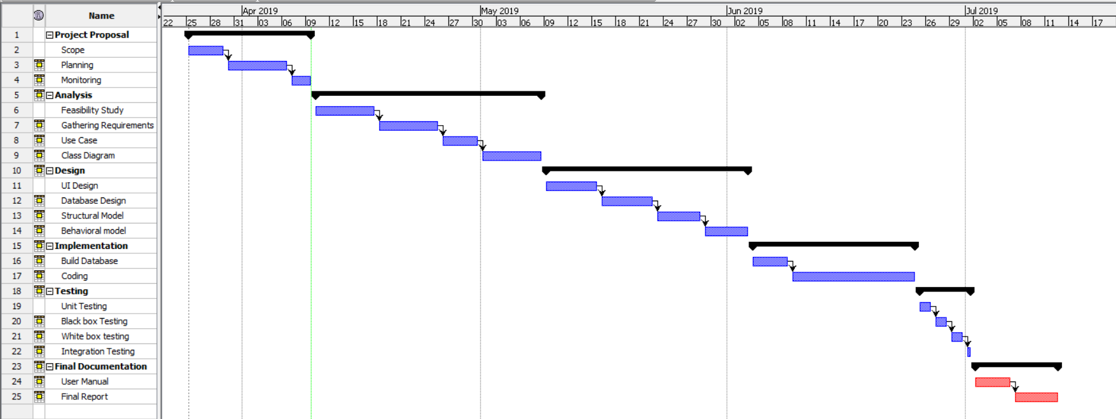

Figure 7: Gantt chart

# Chapter 5: Risk Management

While doing the project we have faces many risk and challenges. There various factor that will cause the problem in the project. To solve those factor below is some solution to those risk:

* Backup data time to time.
* Maintenance the available resources time to time.
* Duplicate data should not be produces which causes sever failure.

**Impact = Likelihood * Consequence**

Risk Likelihood values are shown as follows

|  |  |
| --- | --- |
| Likelihood | Value |
| Low | 1 |
| Medium | 2 |
| High | 3 |

Risk Consequence values are shown below

|  |  |
| --- | --- |
| Consequence | Value |
| Very low | 1 |
| Low | 2 |
| Medium | 3 |
| High | 4 |
| Very High | 5 |

Risk Consequence values are shown below

|  |  |  |  |  |  |
| --- | --- | --- | --- | --- | --- |
| S. No | Risks | Likelihood | Consequences | Impact | Solution |
| 1. | Lack of Skilled Manpower | 1 | 2 | 2 | Hiring skill manpower or providing training to the manpower. |
| 2. | Sever Down | 1 | 4 | 4 | Using cloud storage for backup of data |
| 3 | Lack of resources | 1 | 2 | 2 | Providing the required resources for the developer. |
| 4. | Network Down | 1 | 5 | 5 | There should be provide multiple network connection so that network problem will not occur. |
| 5. | Theft | 2 | 4 | 8 | There should provide access control so that only owner can access to that file. |
| 6. | Staff Theft | 2 | 3 | 6 | Only trusted employee should give permission to access to the data. |
| 7. | SQL Injection | 3 | 3 | 9 | Does not give permission to inject external gadget to system. |

# Chapter 6: Configuration Management

The process of maintaining computer system and software in the automated method in a consistent state is known configuration management. If there is no configuration management is maintain in a automation system or large scale IT system then there will be the chances of increasing risk due to manual error. The aim advantages of configuration management is maintaining consistency system. The importance of configuration management is that it will enables the strength to scale infrastructure and software system without having to correspondingly scale administrative staff to scale manage those system.

To maintain configuration management in my project I have created different folder in where different work will be stored in different folder as shown in below figure.

Git ID: <https://github.com/sabing123/Blood-Donation-and-Donor-Management-System>

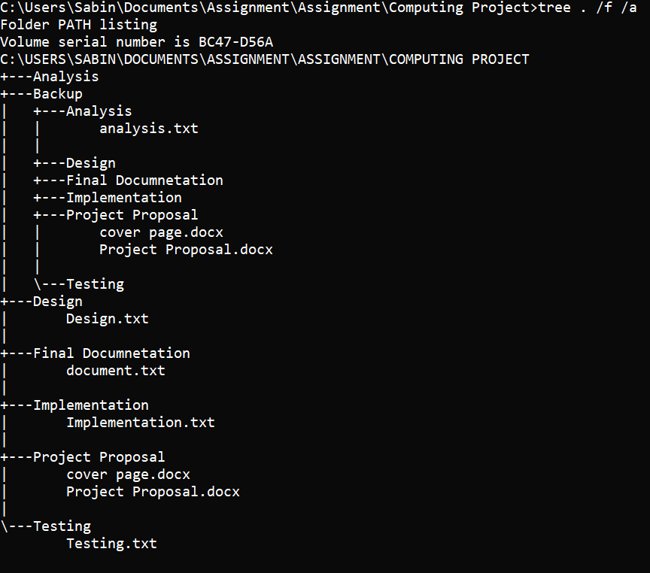

Figure 8: Listing folder directory

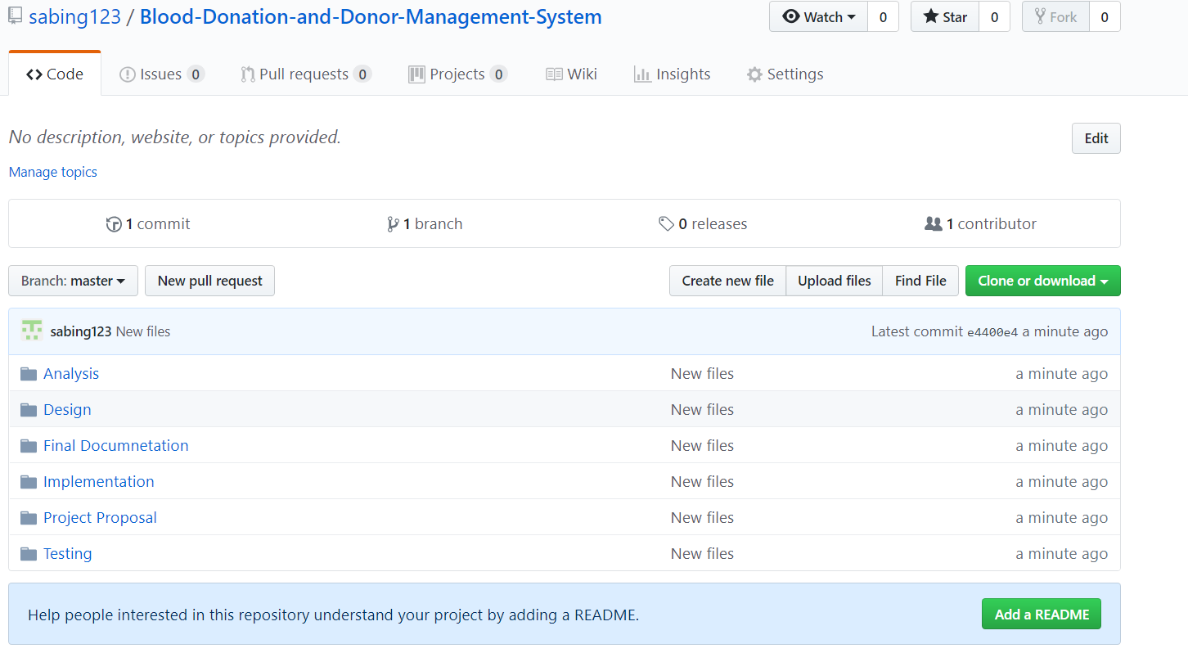

Figure 9: Git Repo

# Conclusion

This project got simple user interface which is very easy for a user to use this program. People can get blood donor detail and can contact to them if they need urgent blood. User can also donate their blood by give some detail. Also blood banks management can also be managed by this program. Finally, I have completed my proposal for this project.

# References

Waterfall Model. 2018. Techspirited. [ONLINE] Available at: <https://techspirited.com/comparison-between-waterfall-model-spiral-model>. [Accessed 8 April 2019].

Izenda. 2017. 3-Tier Architecture. [ONLINE] Available at: <https://www.izenda.com/5-benefits-3-tier-architecture/>. [Accessed 9 April 2019].